COMPUTER PROGRAMING

EX NO - 3

Name: Kakavakam Jaswanth Sai

Roll no: CH.EN.U4CSE20130

Section: CSE-B

Subject code: 19CSE102 LAB

EX NO -3: SIMPLE PROGRAMS USING FUNCTION

1. SUM OF PROPER DIVISORS.

Aim:

To Write a program in C to find sum of the proper divisors using Functions.

Algorithm:

MAIN:

Step 1: Start

Step 2: Declare two variables a, c .

Step 3: input the value of a and call the function Sumofpd(a)

Step 4: Store the value of Sumofpd(a) to c.

Step 5: Print the value of c.

Step 6: Stop

Sumofpd(x):

Step 1: Start

Step 2: Declare int variable sum and initialize to zero.

Step 3: For (int i=1; i<x; i++)

If (x% == 0)

Sum = sum;

Step 4: Return sum.

Program:

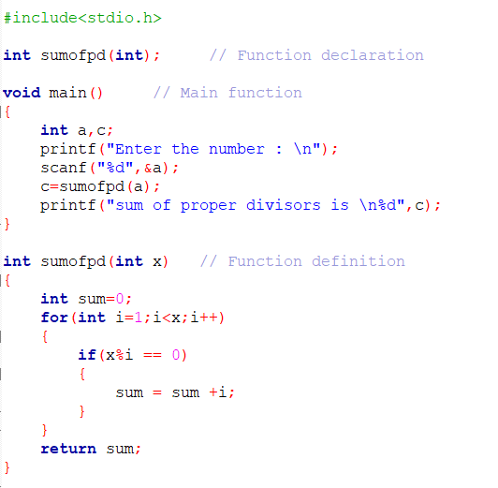

Output:

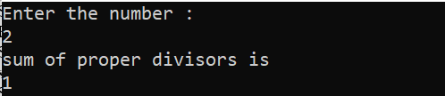 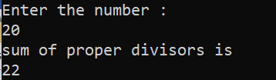

Result:

Thus, the program to find the sum of proper divisors using Functions in C language

has been executed and verified successfully.

1. DIFFERENCE IN LCM AND HCF.

Aim:

To Write a program in C to Print Difference Between LCM and HCF of the given numbers using Functions.

Algorithm:

MAIN:

Step 1: Start

Step 2: Declare three integral variables num1, num2, dif and get the values of num1 and num2.

Step 3: Calculate dif = LCM (num1, num2) – HCF (num1, num2).

Step 4: Print the value of dif.

Step 5: Stop

LCM (x, y):

Step 1: Start

Step 2: Declare three integral variables max.

Step 3: calculate (x>y)? x: y and store to max.

Step 4: While (1)

If (max % x == 0 && max % y == 0)

Break;

max++;

End While.

Step 5: Return max;

HCF (x, y):

Step 1: Start

Step 2: Declare three integral variables hcf.

Step 3: Calculate x\*y/LCM (x, y) and store to hcf.

Step 4: Return hcf;

Program:

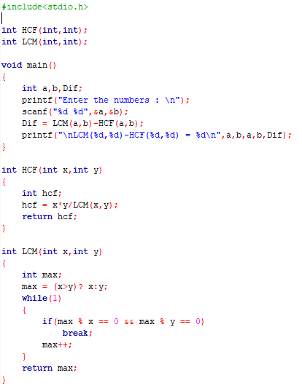

Output:

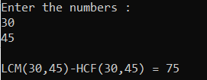 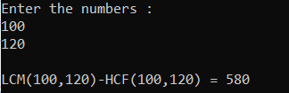

Result:

Thus, the program to find Difference Between LCM and HCF of the given numbers using Functions

in C language has been executed and verified successfully.

1. FRIENDLY NUMBERS OR NOT.

Aim:

To Write a program in C to Print the given numbers are Friendly or not using Functions.

Algorithm:

MAIN:

Step 1: Start

Step 2: Declare three integral variables num1, num2 and get the values of num1 and num2.

Step 3: if (Abun (num1) == Abun(num2))

Step 4: Print given numbers are friendly.

Step 5: else Print Not friendly.

Step 5: Stop

Abun(x):

Step 1: Start

Step 2: Declare int variable sum, r and initialize to zero

Step 3: For (int i=1; i<x; i++)

If (x%i == 0)

Sum = sum;

Step 4: calculate sum/x and store to r

Step 4: Return r.

Program:

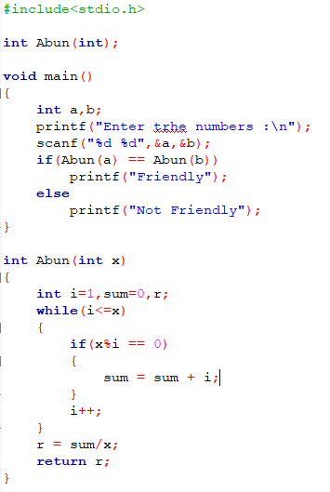

Output:

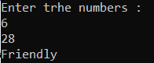 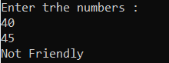

Result:

Thus, the program to find the given numbers are friendly or not friendly using Functions

in C language has been executed and verified successfully.

1. AMICABLE OR NOT.

Aim:

To Write a program in C to Print the given numbers are Amicable or not using Functions.

Algorithm:

MAIN:

Step 1: Start

Step 2: Declare three integral variables num1, num2 and get the values of num1 and num2.

Step 3: if (SOPD (num1) == num2 && SPOD (num2) == num1)

Step 4: Print given numbers are Amicable.

Step 5: else Print Not Amicable numbers.

Step 5: Stop

SOPD (x):

Step 1: Start

Step 2: Declare int variable sum and initialize to zero

Step 3: For (int i=1; i<x; i++)

If (x%i == 0)

Sum = sum;

Step 4: Return sum.

Program:

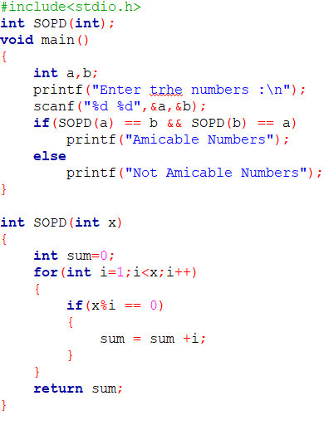

Output:

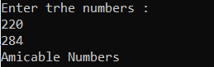 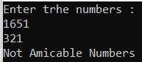

Result:

Thus, the program to find the given numbers are Amicable or not Amicable using Functions

in C language has been executed and verified successfully.

1. SUM OF SERIES.

Aim:

To Write a program in C to Print the sum of $1-\frac{x^{2}}{2!}+\frac{x^{4}}{4!}- ……$ series using Functions.

Algorithm:

MAIN:

Step 1: Start

Step 2: Declare a double variable x and integer n (no of terms). And get the values

Step 3: Call the function Series and print the value of sum.

Step 4: Stop.

Series (x, n)

Step 1: Start

Step 2: Declare double variables sum = 2, term, fct =1, j, y =2, m;

Step 3: for (int i = 1; i < n; i++)

{for (j = 1; j <= y; j++)

{fct = fct \* j;}

term = term \* (-1);

m = term \* pow(x, y) / fct;

sum = sum + m;

y += 2;}

Step 4: Return sum.

Program:

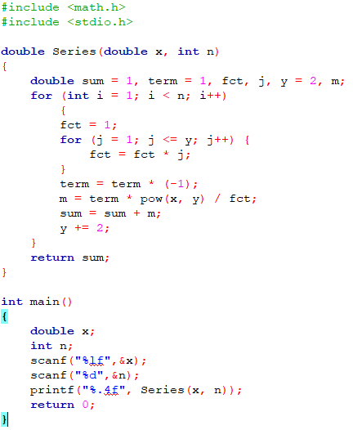

Output:

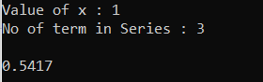 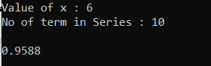

Result:

Thus the program to find the sum of the given series using Functions in C language has been executed and verified successfully.